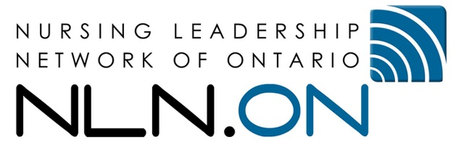

Confidential NLN.ON Award Reference Form for Awards

Deadline for submission: Friday March 31st, 2023 at 11:59PM EST
email to NLN.ON@first-stage.ca in PDF format

Applicant First Name:

Application Family Name:

Award For which They Have Applied (check all the apply):

Part Time Education Award
Dorothy Wylie Graduate Education Award
NLN Research Award Graduate Education
NLN Innovation Seed Grant Award

Please note complete this form in its entirety

Section I
Rate the following criteria (A) through (I) using the numeric score below of 1 to 5. Compare the applicant on each item assessing his/her ability to meet these criteria. As a part of the assessment, take into consideration the experience and education of the applicant.

1 - Poor
2 - Below Average
3 - Average
4 - Above Average
5 - Outstanding

Score |  | Criteria
 |  | Demonstrates commitment to NLN.ON’s vision and goals
 |  | Demonstrates leadership in professional role
 |  | Demonstrates commitment to lifelong learning
 |  | Demonstrates ability to work effectively with groups to achieve goals
 |  | Demonstrates critical thinking and analysis in relationship to learning
 |  | Demonstrates critical thinking and evidence-based practice in professional role
 |  | Demonstrates effective communication skills, both verbal and written
 |  | Demonstrates academic ability to achieve degree
 |  | Demonstrates perseverance to achieve goal
 |  | Total Score

Section II

Based on your knowledge of the applicant, describe any outstanding or limiting characteristics that you consider of special significance: (insert comments below)

Based on your above assessment, would you recommend the applicant for NLN.ON Award:
without reservation
with reservation
do not recommend this applicant

Number of years you have known the applicant: ______ years

In what capacity?

Signature:

Position:

Contact info (email)

Reference letters must be sent in PDF format directly to the NLN office by email to NLN.ON@first-stage.ca

